Query Design and Testing

# Find the time difference on each day between the arrival time and the start time of the course

## Design

|  |  |
| --- | --- |
| **Fields, Calculations** | ClassID, StartTime, ArrivalTime, StartTime – ArrivalTime AS TimeDiff |
| **Tables** | Class, Course |

## SQL Query



## Output

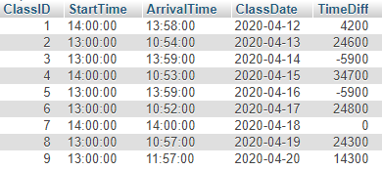

# Find the time difference, in minutes, on each day between the arrival time and the start time of the course

## Design

|  |  |
| --- | --- |
| **Fields, Calculations** | ClassID, StartTime, ArrivalTime, ClassDate, TIMESTAMPDIFF(MINUTE,StartTime,ArrivalTime) AS TimeDiff |
| **Tables** | Class, Course |

## SQL Query



## Output

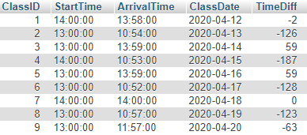

# Take the Difference in minutes query and put it into a ChartJS bar chart

## PHP Code Placed Inside Dataset Entry for ChartJS

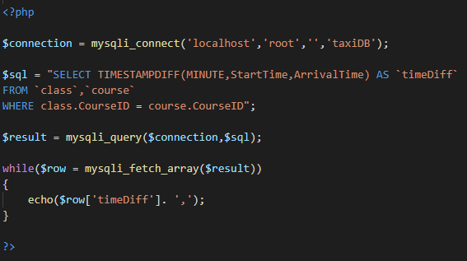

## Output of Chart From Database Interaction

